Common Services


Person Service - Identity Management (PSIM)
Version 2.2.1

OPERATIONS GUIDE

February 2009

Department of Veterans Affairs
Veterans Health Information Technology
Common Services/Identity Management

Revision History

Date | Revision | Description | Author
May, 2006 | 0.1 | Document Created | G. Duff
June, 2006 | 0.2 | Updated for 1.2.1 release. | G. Duff
April, 2008 | 0.3 | Updated for 2.1.4 release. | G. Duff
Oct, 2008 | 0.4 | Removed info about status page because custom queues are no longer used starting with version 2.1.8. Added section about im web app and how to look at HL7InBound servlet. Added troubleshooting section on how to look for HL7 messages. | Dubinsky
Nov, 2008 | 0.5 | Replaced references to im web application with references to psim_webservice web application | Dubinsky
Feb, 2009 | 0.6 | PSIM Tools | D. Rocha

THIS PAGE INTENTIONALLY LEFT BLANK
Table of Contents

1. Introduction 1
1.1. Purpose 1
1.2. Scope 1
1.3. Pre-Requisites 1
1.4. Acronym List 1
2. Administration Tasks 2
2.1. Status Page 2
2.2. Monitoring PSIM Web Application 2
2.3. Start/Stop the service 4
2.4. Monitor JDBC Connection Pools 7
2.5. Administer information about PSIM in NDS 12
2.6. Administer information about PSIM in VIE 12
2.7. Reading the log files 12
2.8. Preparing the PSIM log files for Viewing 13
2.9. Preparing the PSIM HL7 log files for Viewing 13
3. PSIM Tools 14
3.1. PSIM Tools Page 14
3.2. Administration 15
3.3. Messaging 19
3.4. Testing 21
4. Troubleshooting 21
4.1. Tracking HL7 Messages 21
Appendix A. Properties 1
Appendix B. NDS Configuration Entries 1

THIS PAGE INTENTIONALLY LEFT BLANK

Introduction

Purpose
This document contains instructions that should help System Operators in the administration and troubleshooting of the Person Service (PS) software.

Scope
This document describes how to administer the PS software.

Pre-Requisites
- PSIM must be deployed.
- Access to PSIM through WebLogic®
- Access to the ADR database (for certain tasks)

Acronym List
ACRONYM | DESCRIPTION
ADR | Administrative Data Repository
API | Application Program Interface
ASA | Application Server Administrator
DBA | Database Administrator
EAR | J2EE Enterprise Archive
HL7 | Health Level 7
J2EE | Java 2 Enterprise Edition
JDBC | Java Database Connectivity
NDS | National Directory Service
PS | Person Service
PSD | Person Service Demographics
PSIM | Person Service Identity Management
SDS | Standard Data Service
VistA | Veterans Health Information Systems and Technology Architecture

Administration Tasks

Status Page
Starting with version 2.1.8 of PSIM, the PSIM custom inbound and outbound queues are no longer used for message processing. Instead the PSIM web application now not only receives the messages, but does the actual processing and responds with acknowledgements. For the time being the status.jsp page has not been removed from the code (which is why you may still be able to access it), but it is now completely irrelevant to PSIM’s processing.

The new and recommended way to monitor PSIM status is to use the standard WebLogic console (see Monitoring PSIM Web Application) as well as the new PSIM Tools page available at this URL:

http://<server:port>/psim_webservice/admin/PSIMTools.jsp

Note: All of the PSIM administrative functions, including the PSIM Tools page, are now protected with standard J2EE security. Please refer to the PSIM Deployment Guide on how to configure WebLogic user accounts and groups to have sufficient security privilege to access PSIM administrative pages.

Monitoring PSIM Web Application
Use the WebLogic console to monitor the PSIM web application. Using the tree view on the left side of the console, drill down the domain node → Deployments → Applications. Find the PSIM application node and drill down into it. Click on the psim_webservice web application node. Click on the Monitoring tab. You should see a screen similar to this:

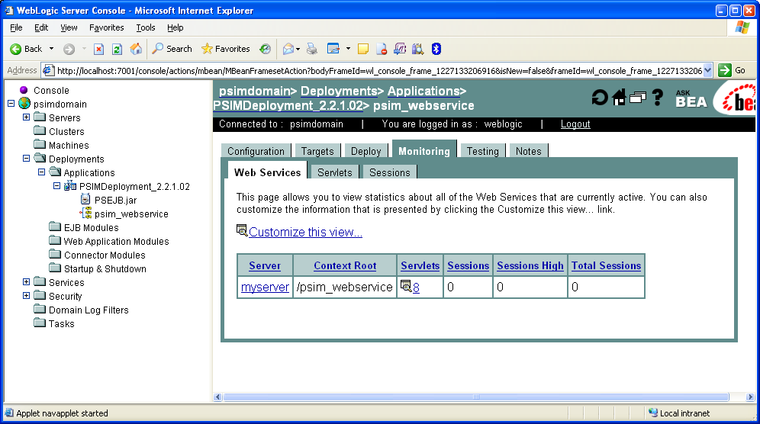

Periodic refreshing of this page will show how many sessions the psim_webservice application is establishing.

Click on the Servlets tab to get a better understanding of how PSIM is reacting to the incoming HL7 message traffic: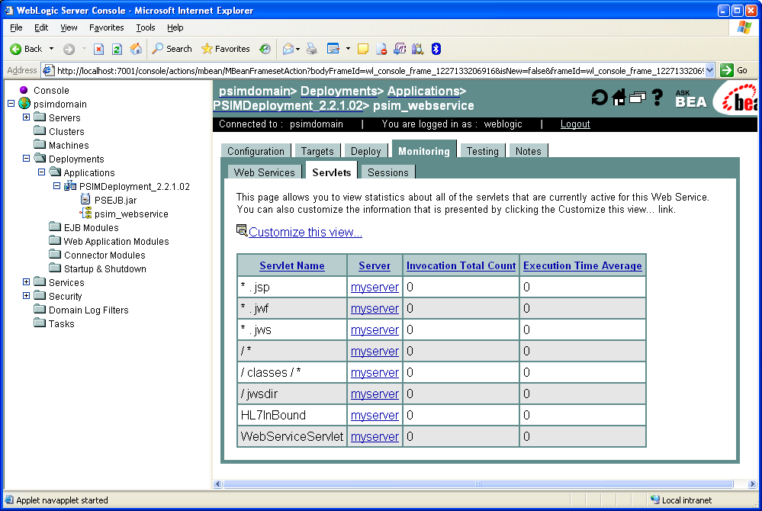

Focus on the HL7InBound servlet row. Each time the servlet receives and attempts to process an HL7 message, the Invocation Total Count value displayed for that servlet will increase by one. The Execution Time Average value contains the average number of seconds a servlet spends processing a message. This time includes the time the servlet spent receiving the message, processing the contents and sending the response back. Keep in mind that Execution Time Average is not necessarily an accurate representation of the overall end-to-end message processing time from the external application’s perspective, because there are other network and software components involved in the overall communication chain and their processing time sometimes can be very significant.

Start/Stop the service
Starting and stopping PSIM is performed using the WebLogic console. After logging in to the WebLogic console, you should receive a screen similar to this:

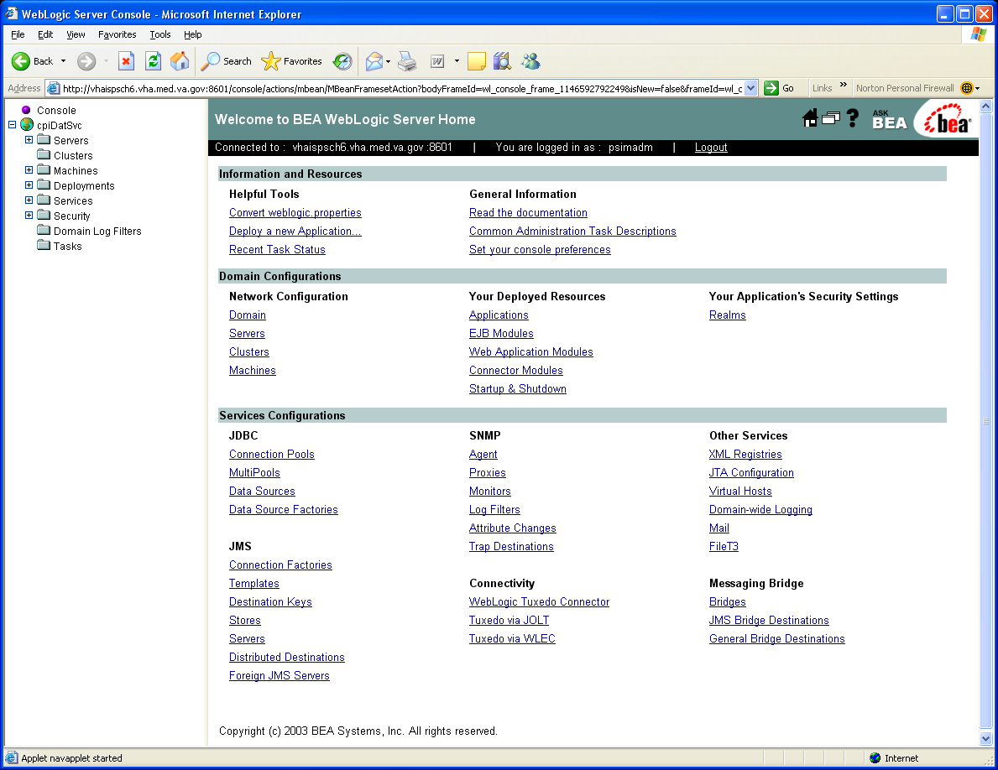

On the left hand side of the page, expand Servers and locate the managed server on which PSIM is executing. Click on the server and the right portion of the page will change to this:

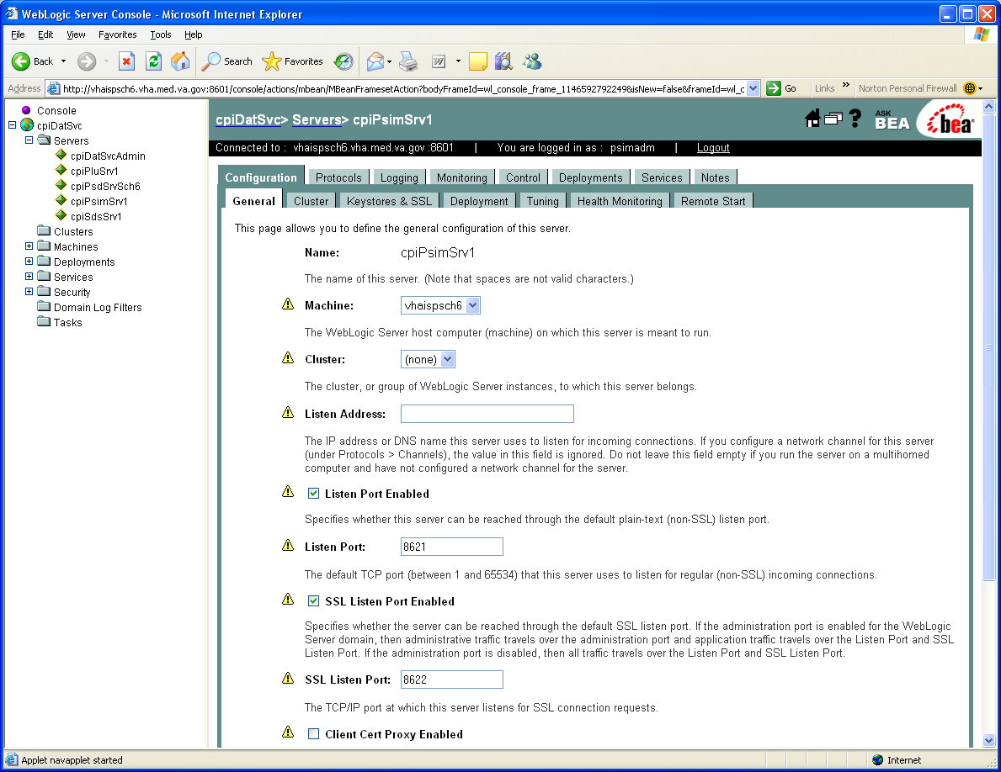

Across the top, you will see several tabs: Configuration, Protocols, Logging, etc. Click on the tab labeled Control and this page will display:

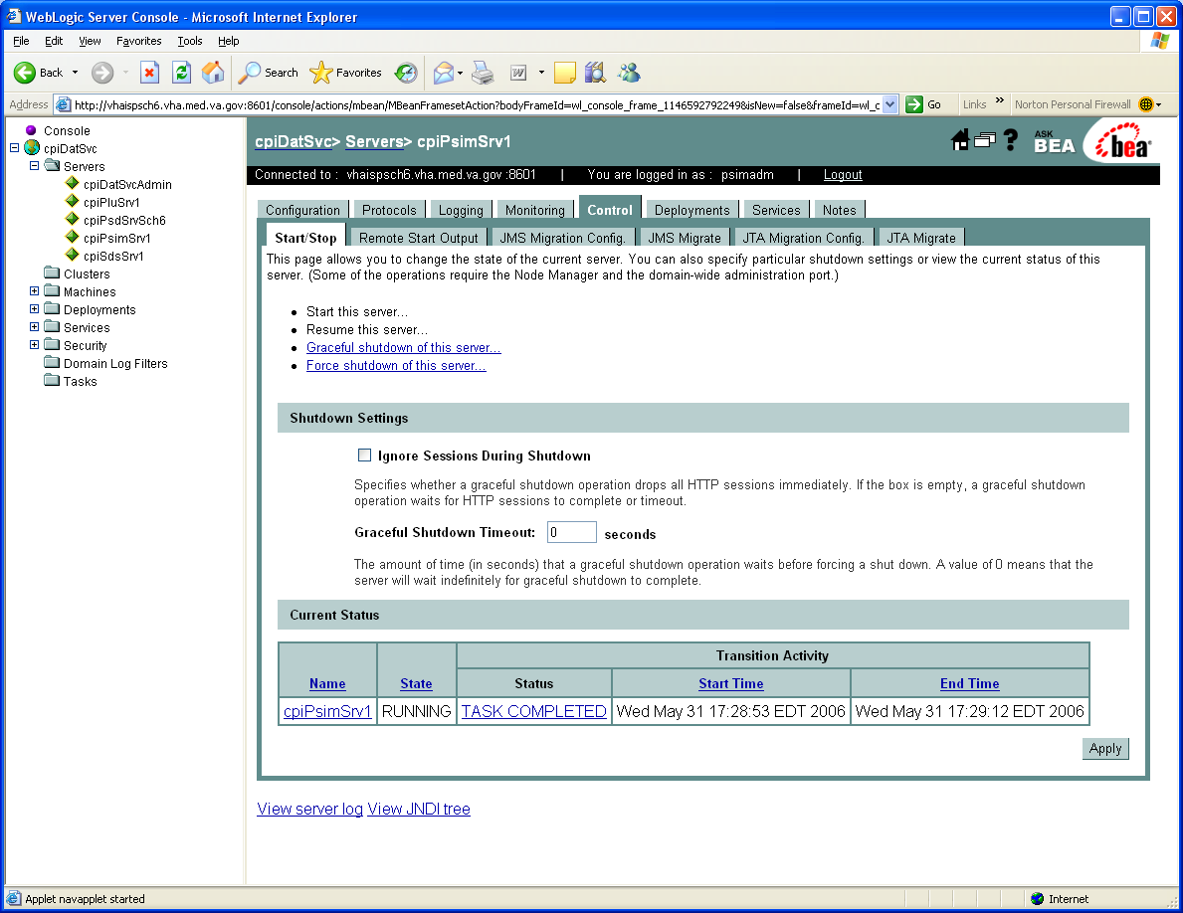

To stop the managed server executing PSIM, click on the Force shutdown of this server … link and click on “Yes” on the resulting page. To start a managed server, come back to this same page and click on the Start this server … link and click on “Yes” on the resulting page. The console will not allow you to start a server that is already executing, or stop a server that is not executing.

Monitor JDBC Connection Pools
Monitoring the JDBC Connection Pools is performed using the WebLogic console. After logging in to the WebLogic console, you should receive a screen similar to this:

Locate and expand Services on the left hand side of the page. Then locate and expand JDBC. Next, click on the Connection Pool entry; your page should change to something similar to this:

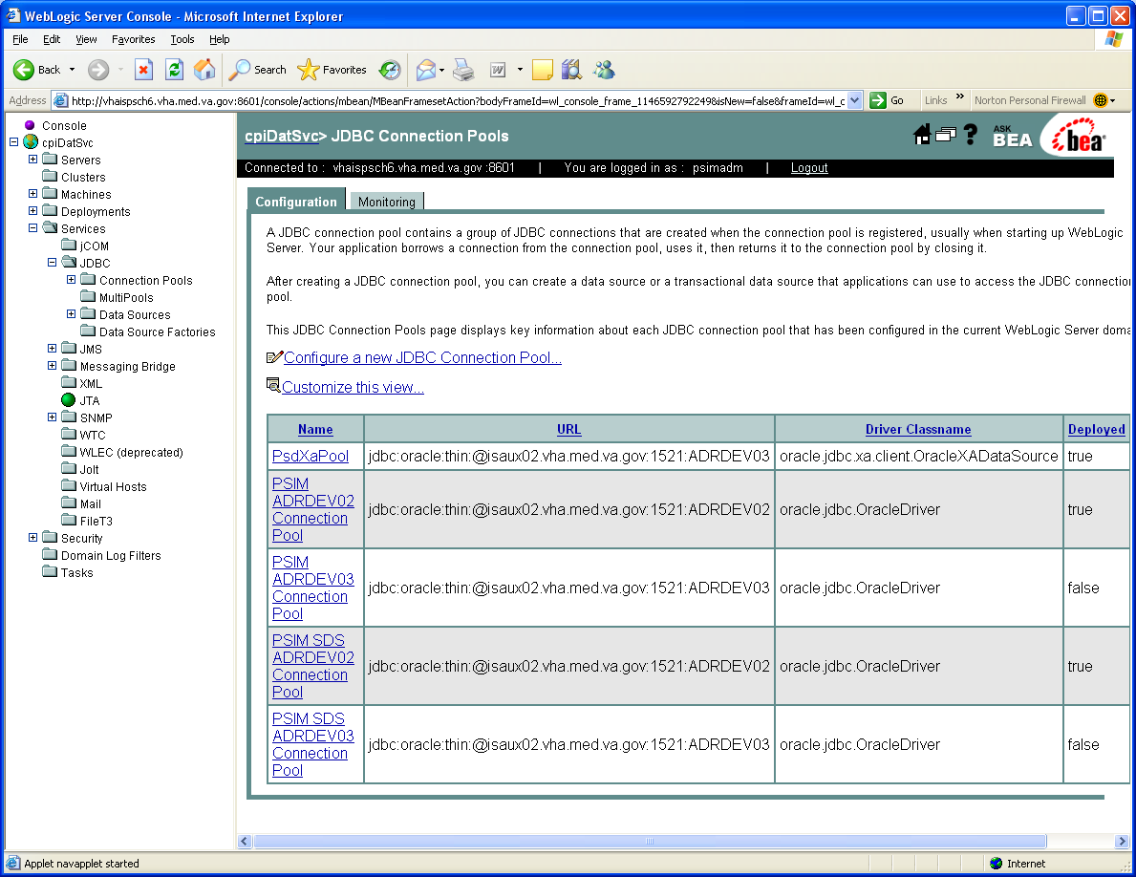

To monitor a specific connection, click on the link for the connection pool name. Your screen will change to something similar to this:

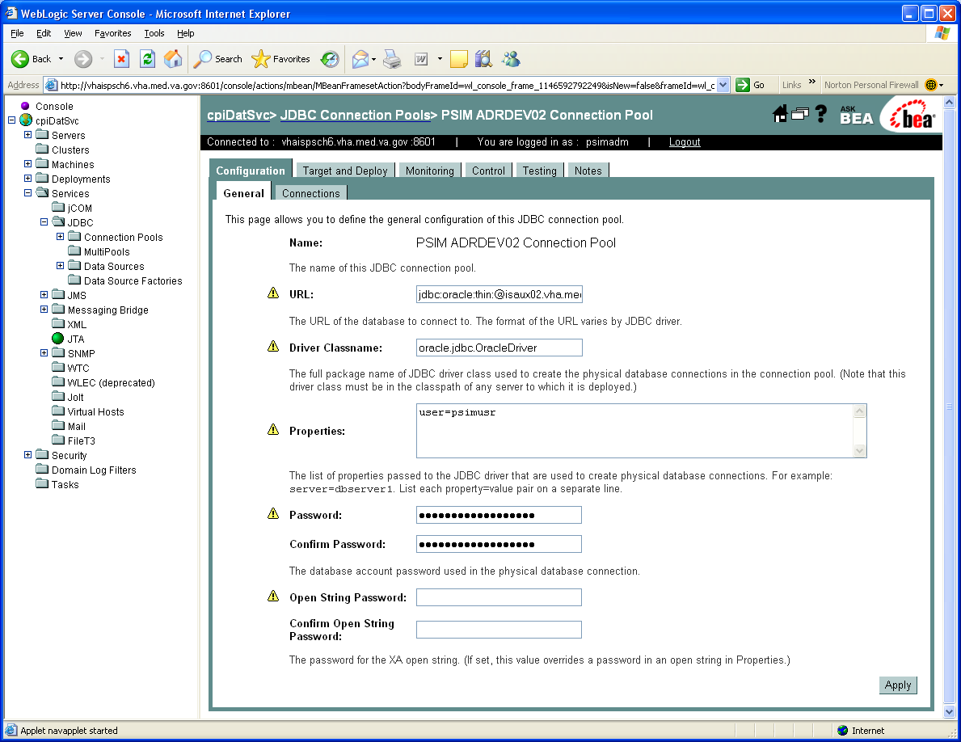

Click on the Testing tab at the top of the page and the following will display:

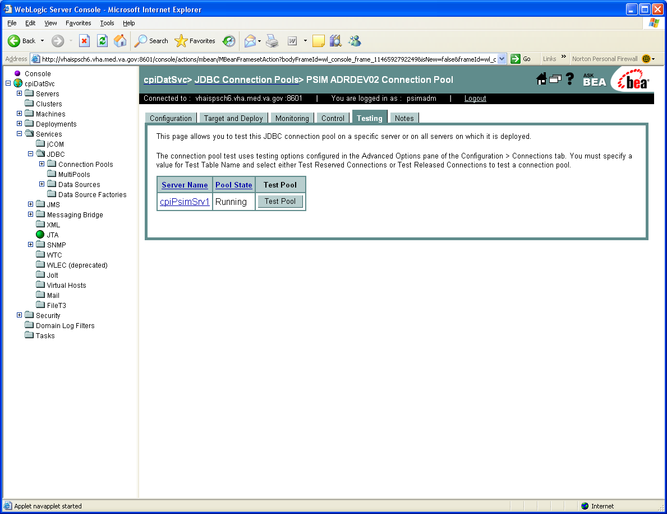

To test to see if the connection pool is still active, click on the [Test Pool] button and you will be told if the pool is executing successfully by a message like this:

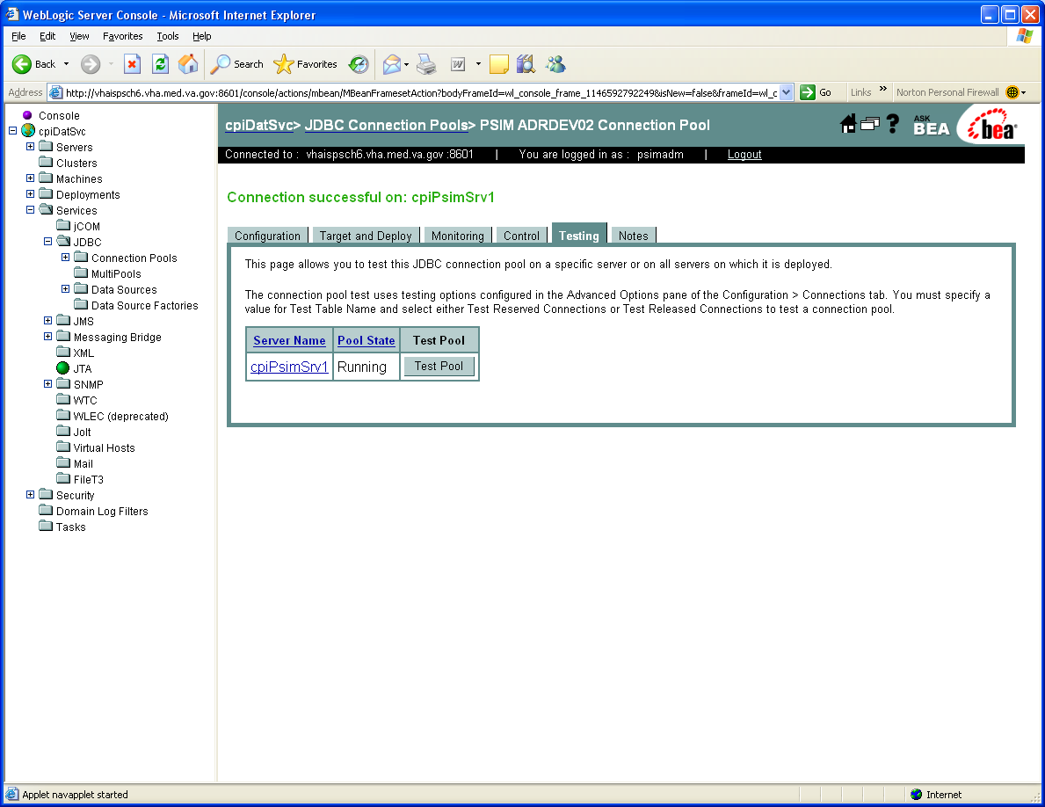

If you receive an error message stating that testing cannot be performed, refer to the PSIM Deployment Guide on how to set up the connection pools for PSIM.

Administer information about PSIM in NDS
Client applications utilize the National Directory Service (NDS) when needing to connect to PSIM. Refer to the NDS documentation about how the user interface (UI) works. The information you will need for NDS is documented in Appendix B – NDS Configuration Entries.

Administer information about PSIM in VIE
All PSIM configuration in VIE is currently performed by the VIE team. Contact the VIE team if you need to update that configuration information.

Reading the log files
The amount of information in the log files generated by PSIM is configurable based upon the LOG4J configuration file. Basically, you should search through the file looking for any ERROR lines to see what has happened.

Preparing the PSIM log files for Viewing
Since PSIM utilizes the Log4J logging facility to log messages, the file that is written out is in a XML format. However, the file as it is written by Log4J is not fully compliant XML. To make the log file viewable in a software tool such as Internet Explorer or Chainsaw, the following steps must be performed.

- Log on to the server where the log files reside.
- Change your current directory to $HEV_HOME/ps/psim.
- Identify the log file you wish to view. PSIM log files are defaulted to be rotated on a daily basis.
- Create a file named PSIMlog.xml and place the following into the file:

<?xml version=”1.0” ?>
<!DOCTYPE log4j:eventSet SYSTEM ”log4j.dtd” [<!ENTITY data SYSTEM “ {filename}”>]>
<log4j:eventSet version=”1.2” xmlns:log4j=”http://jakarta.apache.org/log4j/”>
&data;
</log4j:eventSet>

… where {filename}is the name of the PSIM log file you wish to view.
- If the software you wish to view resides on another server or workstation, copy the PSIMlog.xml, the identified log file and the log4j.dtd files to that server or workstation.
- To view the log file, open up the PSIMlog.xml file using the software of your choice.

Preparing the PSIM HL7 log files for Viewing
Starting with PSIM 2.1.4, PSIM now logs a message every time a new HL7 message arrives. Since these messages are being logged utilizing the Log4J logging facility, the file that is written out is in a XML format. However, the file as it is written by Log4J is not fully compliant XML. To make the log file viewable in a software tool such as Internet Explorer or Chainsaw, the following steps must be performed.

- Log on to the server where the log files reside.
- Change your current directory to $HEV_HOME/ps/psim.
- Identify the log file you wish to view. PSIM HL7 log files are defaulted to be rotated on a daily basis.
- Create a file named hl7log.xml and place the following into the file:

<?xml version=”1.0” ?>
<!DOCTYPE log4j:eventSet SYSTEM ”log4j.dtd” [<!ENTITY data SYSTEM ”{filename}”]>
<log4j:eventSet version=”1.2” xmlns:log4j=”http://jakarta.apache.org/log4j/”>
&data;
</log4j:eventSet>

… where {filename} is the name of the PSIM log file you wish to view.
- If the software you wish to view resides on another server or workstation, copy the hl7log.xml, the identified log file and the log4j.dtd files to that server or workstation.
- To view the log file, open up the hl7log.xml file using the software of your choice.

PSIM Tools

PSIM Tools Page
The PSIM Tools page provides development and system administrators online tools to be able check on system settings and activity for the PSIM application. It is secured by standard J2EE security and can be accessed at the following URL:

http://<server:port>/psim_webservice/admin/PSIMTools.jsp

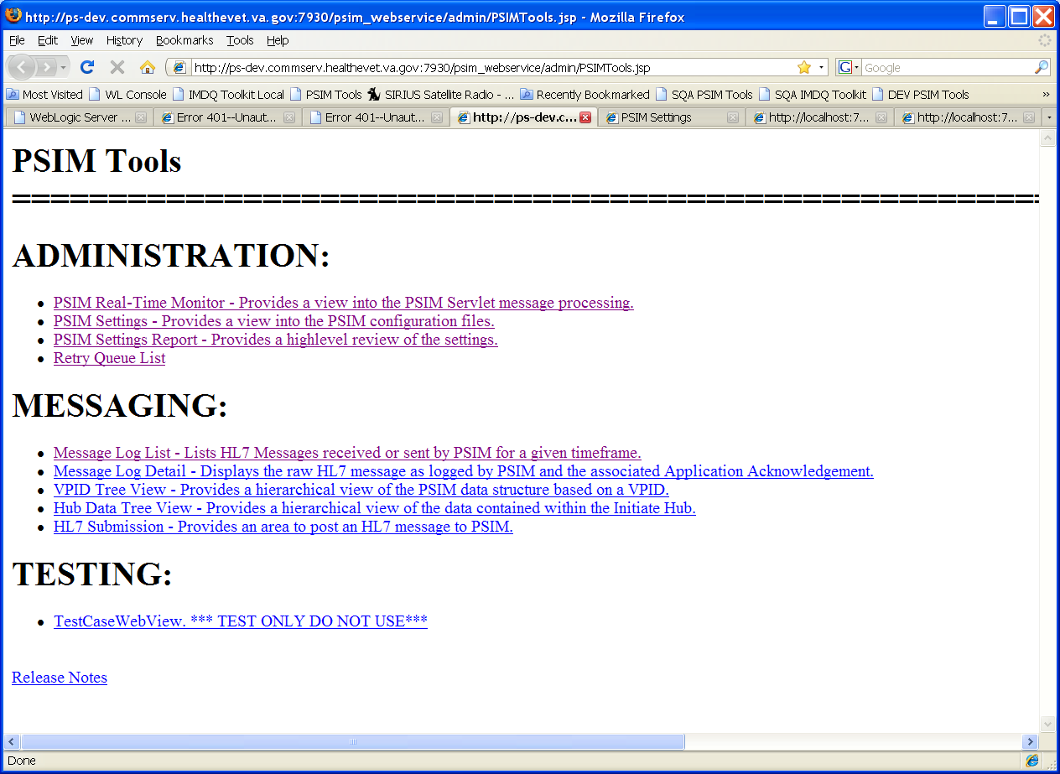

Administration
The administration section provides access to view configuration settings and provide information on the activity in the servlet and the new retry queue.

- PSIM Real-Time Monitor
The PSIM Real-Time Monitor provides a view into the 100 most recent messages sent to the PSIM servlet. It also displays several key pieces of information to identify operating specifics for the instance. This list includes the software version, configured ports, settings location, server information and the databases that the instance is using. All the information should be displayed at startup.
If there are problems with the initial deployment, this page will indicate errors and will give development an idea of what is wrong based on the error message displayed.
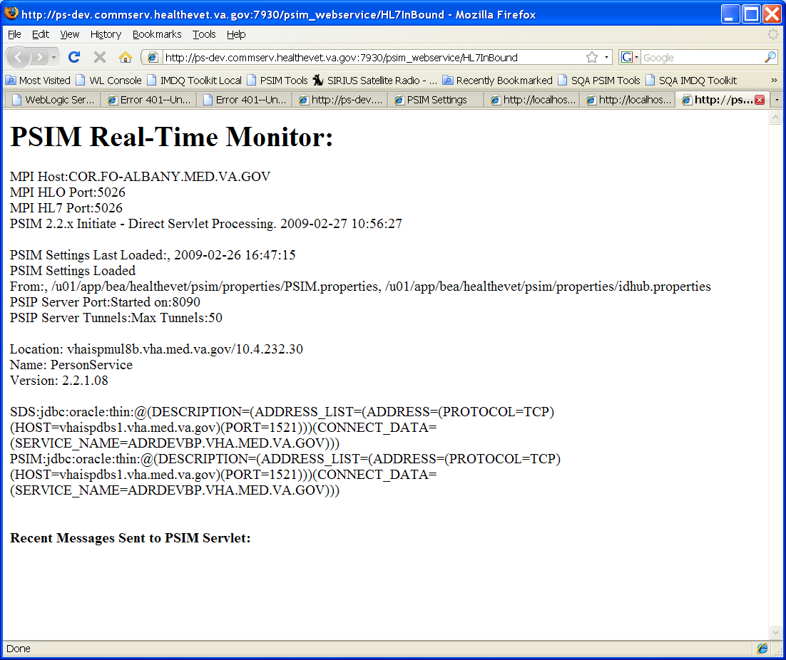
- PSIM Settings
The PSIM Settings page provides a view into the external PSIM configuration files. If there is a question about a configuration setting, the content of the applied configuration files can be displayed. To use the page, select the radio button next to the file you are interested in and select display. The file name will be displayed, with the full path (if it is external) and the contents of the files will be displayed in the text area. If the file is not found an error message will be displayed.
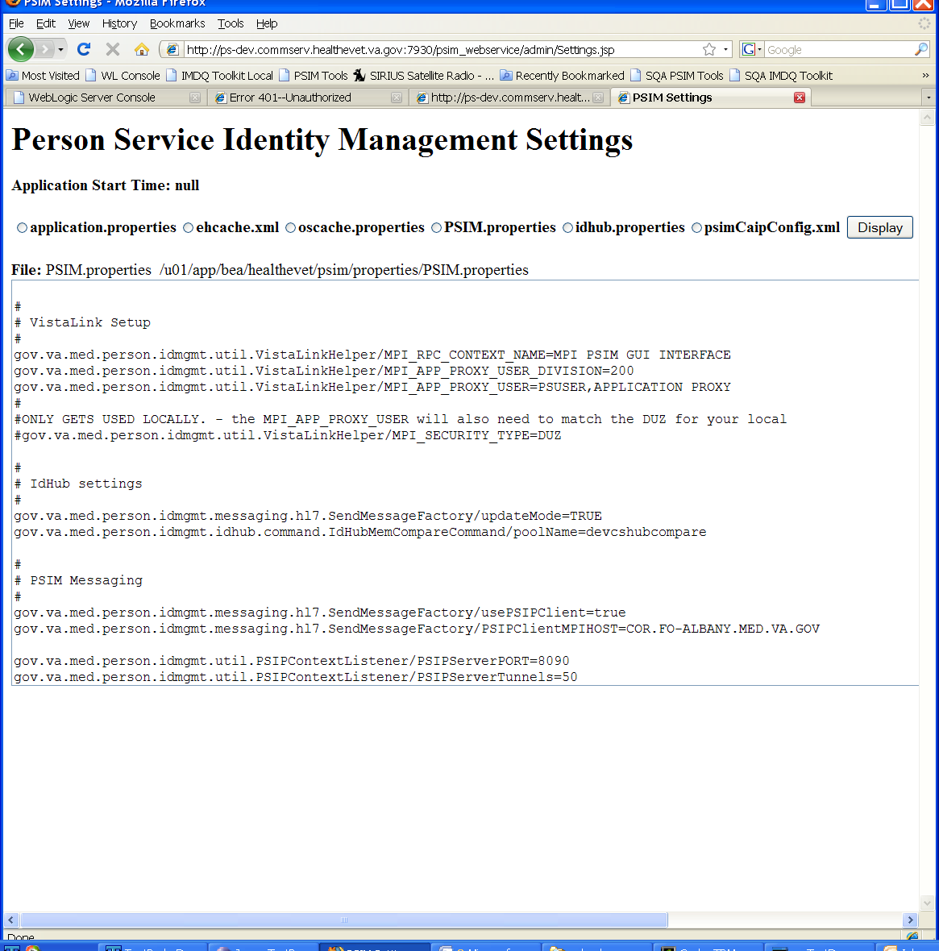
- PSIM Settings Report
The PSIM Settings Report page provides a high level review of the PSIM.properties file settings. Each line of the file is displayed in a three line section on the page. It shows the property name and value on the first line, the associated class name on the second line. The third line detail is still being developed, and it will display a description of the property and how it affects system processing. It will be highlighted in red if the value of the property does not match the expected or recommended value.
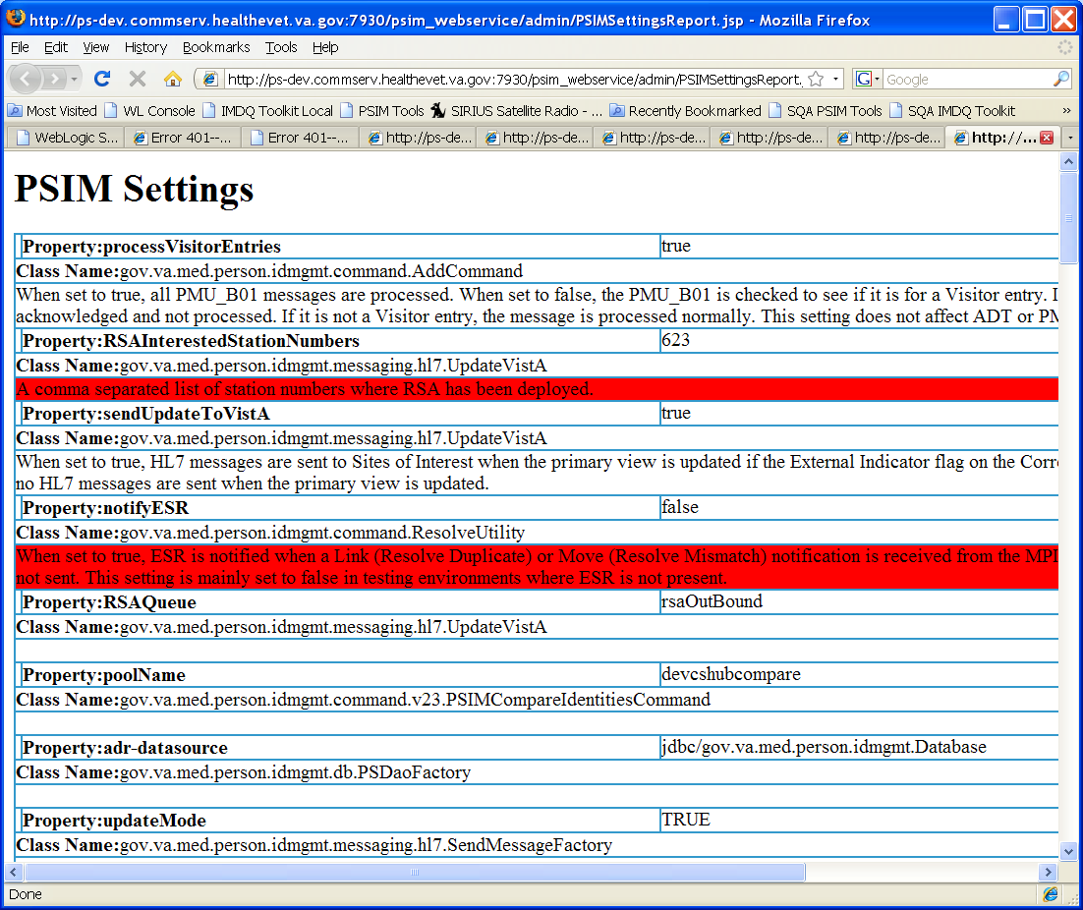

- Retry Queue List
The Retry Queue List page provides operators a view into the messages that are waiting to be processed. The page will display up to a maximum of 1000 events. Retry queue is populated when there is a communication problem that arises between PSIM and MPI tunnel messaging protocol. The system will automatically send the messages in queue once the messaging tunnels have been re-established. Operators can stop the automatic processing by clicking the Stop Auto Retry button and re-enable it by clicking the Start Auto Retry button.
If the retry queue is stopped, the action column will have an action button that will allow the messages in queue to be sent manually.
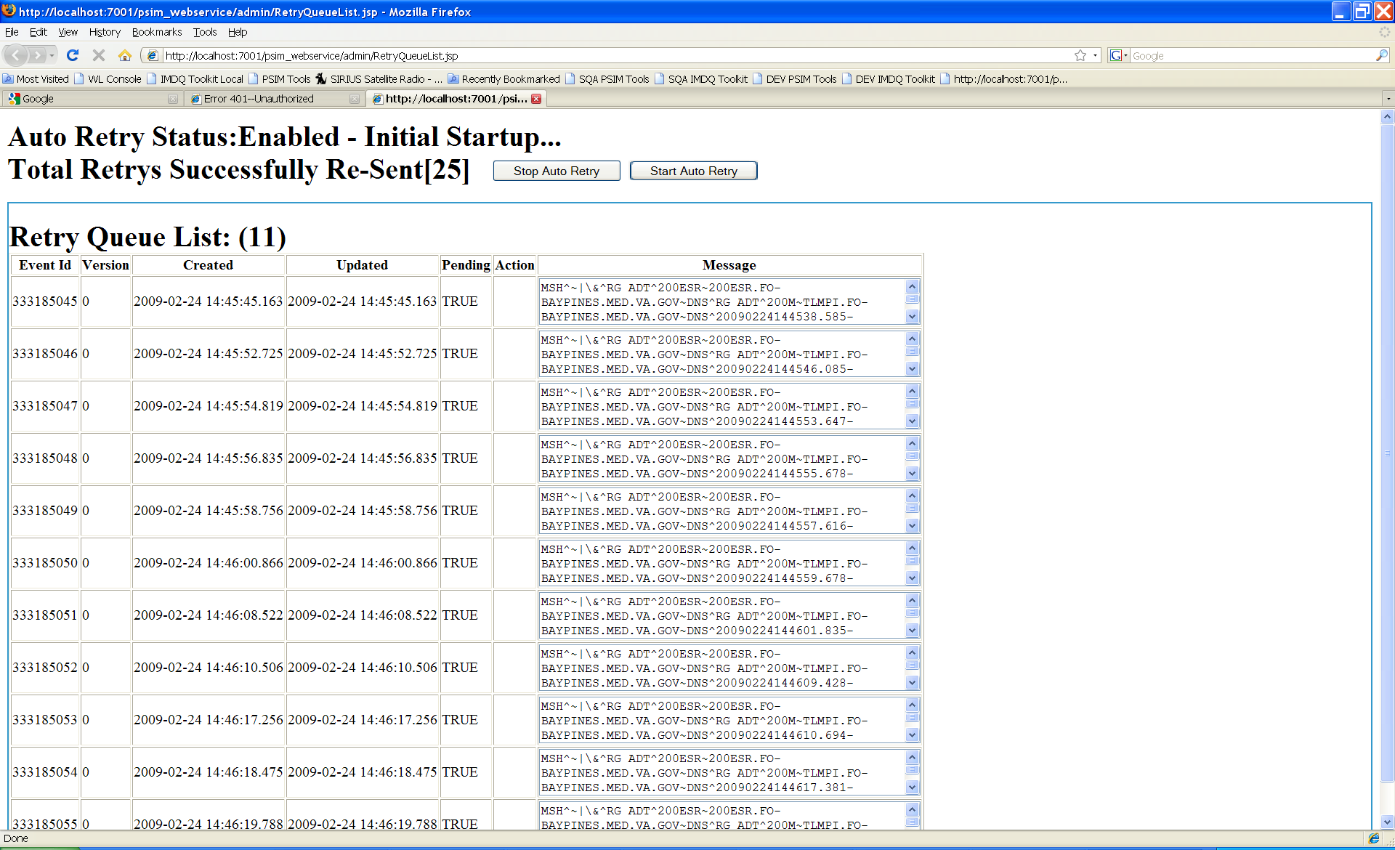

Messaging
- Message Log List
The Message Log List page lists HL7 messages received or sent by PSIM for a given timeframe. To view messages, enter beginning and ending dates in the format MMDDYYYY and click the Submit Query button. The returning list will display the message format, type, ID, number and created date. The Detail button will display the Message Log Detail page for the selected message. Please see the Message Log Detail section for more information.

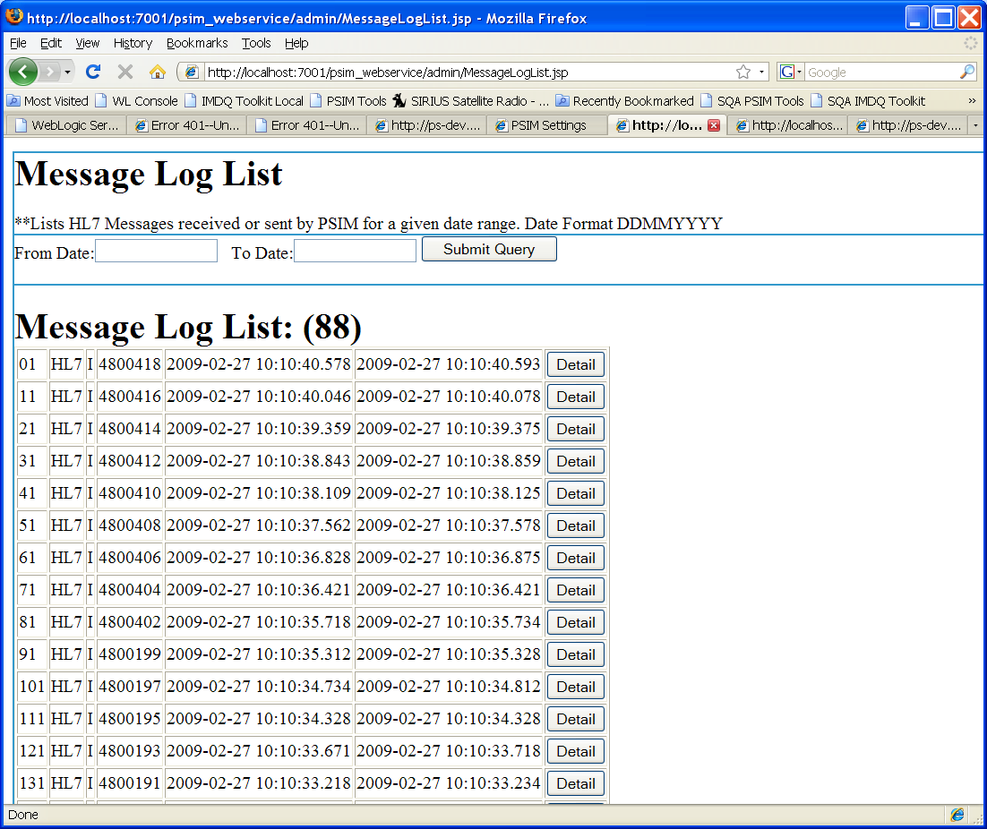
- Message Log Detail
The Message Log Detail page displays the raw HL7 message as logged by PSIM and the associated Application Acknowledgement. This page will be automatically populated if it is accessed via the Message Log List page. If you access this page directly from the PSIM Tools page, enter the message ID of interest and click the Submit Query button. The page will return the original message, the message in XML and the acknowledgement message.

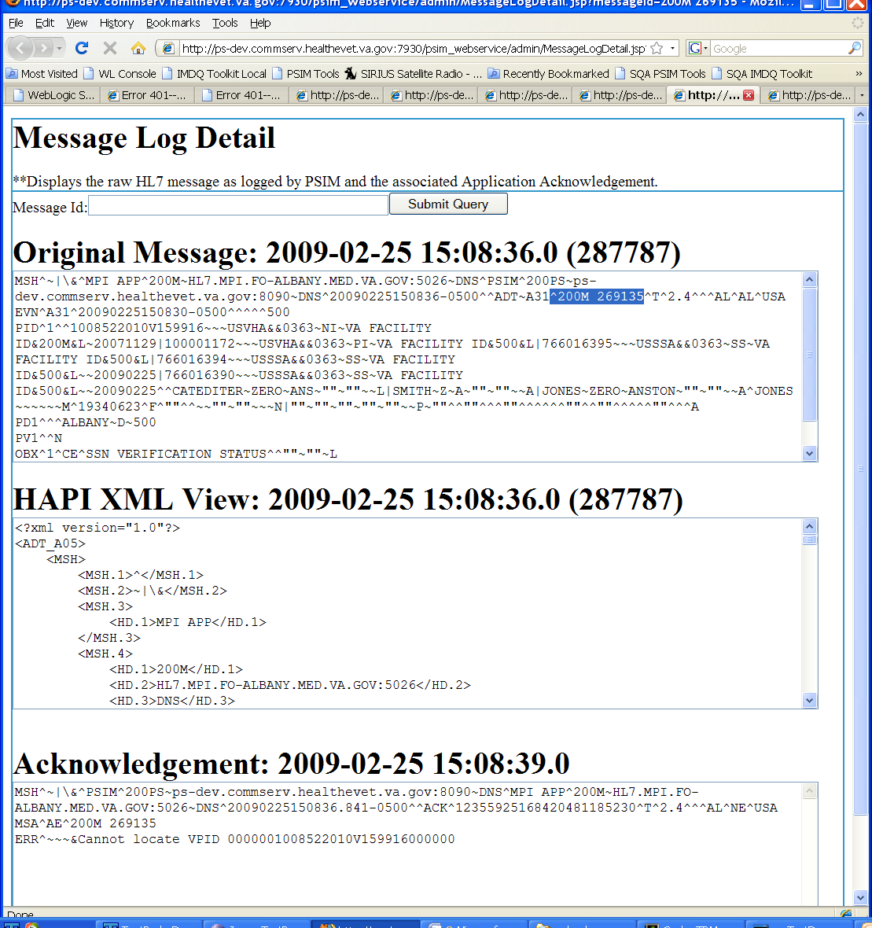

- VPID Tree View
The VPID Tree View page provides a hierarchical view of the PSIM data structure based on a VPID. It can be used to provide development details for troubleshooting a problem. Ender a VPID and click the Get Vpid Tree button. This page is best viewed in Internet Explorer.
- Hub Data Tree View
The Hub Data Tree view provides a hierarchical view of the data contained within the Initiate Hub. It will be used when Initiate is in production and further details will be provided at that time.
- HL7 Submission
The HL7 Submission page provides an area to post an HL7 message to PSIM. It was implemented to be used as a development testing aid.

Testing
The testing section is currently under development and should not be used at this time.

Troubleshooting

Tracking HL7 Messages
Sometimes it’s important to determine if an HL7 message made it into and out of PSIM, and there are a couple of ways to find that out. The first and the easiest way is to look for the message in the database. Another way is to look for the message in the PSIM log files. Whichever method is used, you must first know the message ID of the message you wish to find.

The message ID usually is in the format of 200M xxxxx, where xxxxx is some multi-digit number (e.g., 200M 298064).

Looking for HL7 Message in the Database
Once you know the message ID, all you need to do is query the database like this:

select * from ps_message_log where message_number = '<messageID>';

…where <messageID> is the actual message ID you are looking for. Using our example ID, 200M 298064, the query would look like this:
select * from ps_message_log where message_number = '200M 298064';

If you get one row back as a result, this conclusively proves that the message made it into PSIM. This does not, however, prove that the message was successfully processed or that a response message (acknowledgement) was sent back to the sender. You will need to look for acknowledgement in a PSIM log.

Looking for HL7 Message in PSIM Log Files
PSIM uses two log files to record all HL7 message traffic. The hl7messages.log file is used for all inbound HL7 messages, and the hl7outmessages.log is used for all outbound HL7 messages. In order to determine if a particular message made it into PSIM, all you have to do is to search for that message ID in the hl7messages.log file. If the message is found, the log entry will look something like this:

1309131980 2008-10-02 18:15:48,313 [ExecuteThread: '1' for queue: 'WebLogic.kernel.Default'] WARN gov.va.med.person.idmgmt.messaging.hl7.servlet.MessageServletMultiQueues:logHeader:364 - InBound: MSH^~|\&^MPI APP^200M~HL7.MPI-AUSTIN.MED.VA.GOV:5026~DNS^PSIM^200PS~:8090~DNS^20081002181516-0500^^ADT~A31~^200M 298064^T~^2.4^^^AL^AL^USA

The message acknowledgement will have a different message ID from the incoming message, but it will include the incoming message ID as part of the message body. Therefore, if you search the hl7outmessages.log file for the inbound message ID, you should find the log entry if the message response (acknowledgement) was sent back. It should look like this:

1309133492 2008-10-02 18:15:49,825 [Thread-10] WARN gov.va.med.person.idmgmt.maint.messaging.hl7.factory.BusinessWareMessageDispatcher:send:133 - Successful Outbound message: MSH^~|\&^PSIM^200PS~:8090~DNS^MPI APP^200M~HL7.MPI-AUSTIN.MED.VA.GOV:5026~DNS^20081002181548.944-0600^^ACK^93187252414498439892221^T^2.4^^^AL^NE^USA MSA^AA^200M 298064^^^^ICN=1266625835

If you are not able to locate the message acknowledgement with the given message ID in the hl7outmessages.log file, PSIM did not respond for one reason or another. The next troubleshooting step is to look in the psim.log file for any exceptions that may have occurred while processing the message. Focus on the portion of the psim.log file that contains the output around the same time as the incoming message and you’ll know the time of the incoming message based on the timestamp of the record in the hl7messages.log file. In our example above we would be interested in psim.log entries around the time of 2008-10-02 18:15:48,313.

THIS PAGE INTENTIONALLY LEFT BLANK
- Properties
This section describes properties defined in the application.properties file that should be customized for each deployment. There are other properties in the file that should not be changed.

Java property files are a collection of key value pairs. Each line will have a key associated with it. The key is everything up to the equal (=) sign on the line. The value is everything after the equal sign. Lines can be commented out by placing a hash (#) mark before everything else on the line.

- gov.va.med.term.access.maint.factory.db.hibernate.TransactionFactory/hibernate.dialect

This setting tells Hibernate what SQL dialect to use. Valid values for this property are:

When accessing this type of database | The value should be
Oracle 9 or 10 | net.sf.hibernate.dialect.Oracle9Dialect
Caché | net.sf.hibernate.dialect.GenericDialect

- gov.va.med.term.access.maint.factory.db.hibernate.TransactionFactory/hibernate.connection.datasource

This setting tells Hibernate what JNDI name to use in order to locate the connection pool configured for PSIM’s use. The value for this setting should always be jdbc/gov.va.med.person.idmgmt.Database.

- gov.va.med.term.access.util.ImplementorRegistry/gov.va.med.term.access.maint.util.Task

This property tells the ContextListener class what HL7 message processors to start up. These processors are started when the PSIM server is started. If these values do change, remember to update the web.xml file in the PSIMWeb war file appropriately.

The servlet-class setting for the HL7InBound servlet in the web.xml file also needs to be set to gov.va.med.person.idmgmt.messaging.hl7.servlet.MessageServletMultiQueues when this setting is used.

The servlet-class setting for the HL7InBound servlet in the web.xml file also needs to be set to gov.va.med.person.idmgmt.messaging.hl7.servlet.MessageServlet when this setting is used.

- gov.va.med.term.access.maint.messaging.hl7.factory.BusinessWareMessageDispatcher/url

The value for this setting should be the URL for the VIE server that PSIM should utilize in sending outbound HL7 messages. This value will change depending upon the location of the PSIM deployment and the VIE server defined for that environment.

An example value is http://vhaispviev3.vha.med.va.gov:8080/fwclient2/Framework2ServletHTTPtoChannel.

- ca.uhn.hl7v2.model.Message/processingID

This value tells the HL7 messaging system what the processing identifier for this deployment is. These values correspond to the HL7 Table 0103 defined in the HL7 specification. There are only three possible values for this property:

Deployment Usage | Value
Development | D
Training | T
Production | P

- ca.uhn.hl7v2.model.Message/hl7SpecificationVersion

This value tells PSIM what HL7 specification version to use. The only supported value at this time is 2.4.

- ca.uhn.hl7v2.model.Message/hl7MPIDomainName

This value tells PSIM what the domain name is for the MPI instance when sending HL7 messages about patients to the MPI. This domain should be registered in VistA. An example domain name is TLMPI.FO-BAYPINES.MED.VA.GOV.

- ca.uhn.hl7v2.model.Message/hl7PSIMDomainName

This value tells PSIM what the domain name is for the PSIM instance when sending HL7 messages about patients to the MPI. This domain should be registered in VIstA. An example domain name is 200PS.FO-BAYPINES.MED.VA.GOV.

- gov.va.med.person.idmgmt.command.CommandBase/multipleVpidThreshold

This value tells PSIM what the maximum number of VPIDs to accept is when the obtain(IQualifiedIdentifier[]) and it’s overloaded methods are. Currently, the default value is 25. This value should not be changed without input from the business community.

- gov.va.med.person.idmgmt.command.Add/sendQueryToMPI

PSIM still has the functionality to query the MPI when an “Add” message is received. The default value of “false” turns off this functionality. To turn the functionality back on, use a value of “true”-- but consult with the business community before making this change.

- gov.va.med.person.idmgmt.command.Obtain/lookupThreshold

This value tells PSIM what the maximum number of persons to return from an Attended Lookup is. The default value for this property is 10. Consult the business community before changing this value.

- gov.va.med.person.idmgmt.messaging.hl7.UpdateVistA/sendUpdateToVistA

PSIM has the ability to send updates to a VistA New Person File when the primary view for a person changes. This functionality is by default turned off (value equals “false”) when PSIM is built. To turn on this functionality, set the value to “true”. Consult the business community before changing this value.

- gov.va.med.person.idmgmt.messaging.hl7.UpdateVistA/RSAReceivingAppName

PSIM has the ability to send HL7 messages to RSA when RSA registers interest in a site (see RSAInterestedStationNumbers below). This value is placed into the HL7 header as the receiving application name when a message destined for RSA is generated.

- gov.va.med.person.idmgmt.messaging.hl7.UpdateVistA/RSAStationNumber

When PSIM generates an HL7 message destined for RSA, this is the station number that is placed in to the HL7 message header for routing purposes. The default value is 200RSA.

- gov.va.med.person.idmgmt.messaging.hl7.UpdateVistA/RSAInterestedStationNumbers

This property tells PSIM what station numbers RSA has registered an interest in. This is just a comma separated listed of station number (e.g., 623,589,987).

- gov.va.med.person.idmgmt.messaging.hl7.UpdateVistA/RSAQueue

This property tells PSIM what outbound queue to use when sending messages to RSA. The default of “rsaOutBound” is queue that messages are not automatically sent from. This is done for testing purposes where there may not be an RSA instance. To automatically send HL7 messages, change the value to “outbound”.

- gov.va.med.person.idmgmt.PersonVPIDUtil/notifyESR

This property tells PSIM if ESR should be notified of Resolve Duplicate or Resolve Mismatch events. The default setting of false is used for testing when an ESR instance may not exist. If an ESR instance does exist, change this value to true.

- gov.va.med.person.idmgmt.util.NameStandardization/maxFirstNameLength

This property tells PSIM what the maximum length of a person’s first name should be. The default setting is 25. Consult the business community before making changes to this value.

- gov.va.med.person.idmgmt.util.NameStandardization/maxMiddleNameLength

This property tells PSIM what the maximum length of a person’s middle name should be. The default setting is 25. Consult the business community before making changes to this value.

- gov.va.med.person.idmgmt.util.NameStandardization/maxLastNameLength

This property tells PSIM what the maximum length of a person’s last name should be. The default setting is 35. Consult the business community before making changes to this value.

- gov.va.med.person.idmgmt.util.NameStandardization/maxSuffixLength

This property tells PSIM what the maximum length of a person’s suffix should be. The default setting is 10. Consult the business community before making changes to this value.

THIS PAGE INTENTIONALLY LEFT BLANK
- NDS Configuration Entries

NDS Admin Tab | NDS Field | Transport  Technology | Usage | Value or Hint
Service Providers | Provider team name | All | Id of the service provider | PSIM
Service Providers |  Entries |  Details | Signature | All | Fully qualified class name of business delegate implementation | gov.va.med.person.delegate.ISignature
Service Providers |  Entries |  Details | Description | All | Description of the service | The Person Service Signature
Service Providers | Entries | Versions | Details | Description | All | Description of the Version | Person Service Version 1.0.0.0
Service Providers | Entries | Versions | Details | Major Version | All | Service’s version information | 1
Service Providers | Entries | Versions | Details | Minor Version | All | Service’s version information | 0
Service Providers | Entries | Versions | Details | Revision Number | All | Service’s version information | 0
Service Providers | Entries | Versions | Details | Build Number | All | Service’s version information | 0
Service Providers | Entries | Versions | Service Endpoints | Details | Description | All | Description of the service endpoint | Enter a description of the service end point
 | Implementa-tion Class Name | All | Business delegate interface fully qualified name | gov.va.med.person.delegate.PSDelegate
 | JNDI Name | Remote EJB | JNDI name of service’s home interface | Ejb/PSBean
 | JNDI Name | Local EJB | JNDI name of service’s home interface | Not used
 | JNDI Name | JMS | JNDI name of service’s JMS Queue or Topic | Not used
 | JNDI Name | Web Service | Not used | Not used
 | Provider | Remote EJB | Fully qualified Initial Context Factory class | WebLogic.jndi.WLInitialContextFactory
 | Provider | Local EJB | Fully qualified Initial Context Factory class | WebLogic.jndi.WLInitialContextFactory
 | Provider | JMS | Fully qualified Initial Context Factory class | WebLogic.jndi.WLInitialContextFactory
 | Provider | Web Service | Web service proxy object fully qualified name o | Not used
 | JMS Factory Location | Remote EJB | Not used | Not used
 | JMS Factory Location | Local EJB | Not used | Not used
 | JMS Factory Location | JMS | JNDI name of Queue/Topic Connection Factory | Not used
 | JMS Factory Location | Web Service | Not used | Not used
 | Technology | All | Service transport technology | EJB Remote
Service Providers | Entries | Versions | Service Endpoints | Physical Endpoints | Details | Description | All | Description of the Physical Endpoint | Enter a description of the physical end point.
 | Service State | All | Availability of service | Available
 | Principal, Credential | Remote EJB | User ID, password to application server hosting service | Enter the user ID and password used to access the APIs.
 | Principal, Credential | Local EJB | User ID, password to application server hosting service | Enter the user ID and password used to access the APIs.
 | Principal, Credential | JMS | User ID, password to application server hosting service | Enter the user ID and password used to access the APIs.
 | Principal, Credential | Web Service | Default user ID and Password to web service
 | Protocol | All | The network protocol used to access the service | t3
 | Server Address | All | The IP address or the DNS name of the server hosting the service | Enter the DNS name of the server that is executing PS.
 | Port Number | All | The port number the application server is listening to | Enter the port number of the WebLogic managed server executing PS.
 | Service Path | Web Service | The path to the WSDL document | Not used
Service Providers | Entries | Versions | Service Endpoints | Physical Endpoints | Site App Deployments | Details | Node | All | Site name | Such as SOIPlano
 | Application | All | Application name | Such as PatientApp
 | Priority | All | Integer value indicating relative priority of this service entry to other entries with same signature, version, implementation name, site, and application | 1  Note: CAIP considers the entry with the lowest value priority to be the “primary” service

